2025 TRACKING COURSE ANNOUNCEMENT

Date: June 6, 7, 8, 2025
Time: 8:00 a.m., Friday, June 6, 2025 through 2:00 p.m., Sunday, June 8, 2025

Location: Union Rogue Missionary Baptist Camp, Prospect, OR.
The camp is located north of the town of Prospect off Highway 62 in Jackson County.
For driving directions from your location, go to http://www.unionroguerivercamp.com
See the last page for maps and more directions.

Course Cost: The Course fee for Tuition, Room and Board is $450.00 for this three-day class. Students can receive a $20 discount on their course fees by pre-registering, with their enclosed course fee of $430.00, (payable to Pacific Crest Trackers Association (PCTA)), before May 20, 2025.

A $100 deposit is required to reserve space in this class at full tuition, no later than May 31, 2025.

Class fees should be sent to: Pacific Crest Trackers Association (PCTA), 2689 Ojai Drive NW, Salem, OR 97304.

All student fees for Tuition, Room and Board must be received before the commencement of class on June 6th, 2025.

Meals & Accommodations: Dormitory style accommodation is provided Thursday through Saturday nights. Meals and snacks are provided from Friday breakfast through Sunday lunch. Students must bring their own sleeping bags, pillows, towels, and toiletries.

There are NO prerequisites for this training presentation. This tracking course is open to all persons with tracking interests regardless of previous experience or training and will focus on primary training for beginning or novice student interests. This will be a certification course for all eligible students. All tracking students will be provided training at an appropriate level for their development and upward progress.

Course Content: This will be a 24-hour course beginning at 8:00 am Friday, June 6th with registration and lecture including power point presentation to provide Novice and Basic tracker understanding of training methodology, techniques and procedures. The presentation supports field training by providing student understanding of training methods, manner and objectives.
“Tracking” is a first response primary search resource used to verify witness statements, establish the “PLS”, direction of subject travel and following the physical evidence to the missing person. Field training will allow “student tracking team” experimentation and “hands-on” practice of fundamental tracking techniques. Novice students will progress from initial identifying a print, to “step-by-step” every track concept of following an identified sign line and practical tracking team response.

This is a “skill development” training program for Apprentice and Journeyman Tracker students. Students at these levels have acquired Basic Tracker understanding and will be introduced to practical tracking techniques and applications necessary to become a viable resource for SAR missions. Students at all training levels will be individually challenged with additional advanced tracking concepts and techniques. Journeyman Tracker students will be provided advanced training objectives working with Novice and Apprentice students and separately in simulated actual SAR and law enforcement mission scenarios.

Please bring to this training course your current training manual and tracking logs.
Should you anticipate challenging the certification board for advancement: Please advise your trainer and the Lead Instructor at least 30 days in advance so that person may prepare a recommendation and your training records; you must bring your personal tracking and training logs and records.

Student Needs: Students should be physically fit and equipped for SAR field response. Field practice will continue during any inclement weather, students should be properly prepared with wet/dry, cold/hot weather gear. Knee pads may be helpful. Students need to bring a pen/pencil, note pad, small measuring tape, a three-cell flashlight and a 5/8 inch doweling or similar, 36 to 40 inches long, with three rubber bands on it to use as a tracking stick.

Registration: Students are encouraged to pre-register no later than May 20, 2025 for this course and take advantage of the pre-registration discount. If you have any questions regarding the class or class location, please contact Dan Huckins at (541) 890-4445 or by email at inspectir@gmail.com.

Send your course fees to: Pacific Crest Trackers Association (PCTA), 2689 Ojai Drive NW, Salem, OR 97304.

Payment can also be made using PayPal to pacificcresttrackers@gmail.com . An $8.65 fee will be added using this method of payment for the full fee, $2.48 if only paying the deposit. Just add the appropriate fee to your payment.

Pre-registered students failing to attend this course without a reasonable excuse will be assessed the $100.00 service fee.

Sponsor Information: This course is sponsored by Pacific Crest Trackers Association, an affiliate of the JHPTS Visual Tracking and Training program in order to provide tracking training and tracking resources across Washington, Oregon, and California. All interested law enforcement and SAR volunteer personnel are invited to attend.

Signed copies of Joel’s book are available by direct contact with Joel at Joel@jhardin-inc.com

TRAINING COURSE REGISTRATION
Course Applicant: Please complete this form and send $100.00 deposit check or full payment (unless already paid via PayPal) made out to PCTA via regular mail no later than May 20, 2025 to: Pacific Crest Trackers Association (PCTA), 2689 Ojai Drive NW, Salem, OR 97304

Course Location: | Union Rogue Missionary Baptist Camp, Prospect, OR
Course Date: | June 6 – 8, 2025
Course Name: | Tracking
Student Name:
Mailing Address:
City:
Prov/State: | Postal Code:
Phone #: | Group/Unit/County:
E-Mail Address:
Current JHPTS Certification | (please check one) (you may double click on the appropriate square and change the default value from Not Checked to Checked)
New Student | Basic Tracker | Apprentice Tracker
Journeyman Tracker |  | Sign Cutter
Deposit Enclosed $100.00 | Tuition Fee Enclosed $____________
Applicant: Please note any requests, dietary needs or questions that you have and wish a response from the contact person.

Directions and Maps:
From Medford: https://goo.gl/maps/ccW5WrsCPhTSbr8x5
From Roseburg: https://goo.gl/maps/TFXsAEiJsFrPvvyi7
From Eugene: https://goo.gl/maps/jP75kBP9AKFL8wDf7
From Bend: https://goo.gl/maps/y6sfHLTSyFLmQuQNA
From Klamath Falls: https://goo.gl/maps/tBfM5hyQZnEpavc49

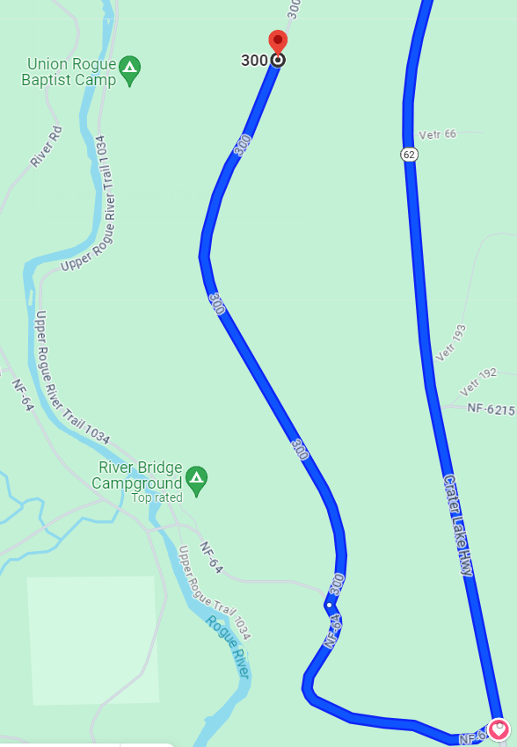
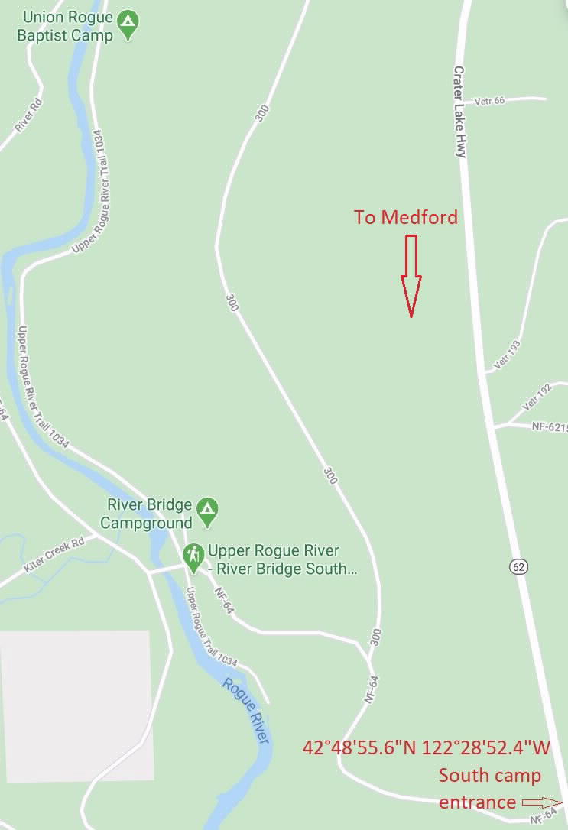
After you turn off Hwy 62 and travel up the road there will be a sign directing you to the camp. The south entrance is easier to follow than the north entrance and is the entrance to use. There will not be directional signs posted on the north entrance. This is a dead zone for cell phones and Google Maps will take you to the wrong area so it is important to plan ahead, print the map if necessary and follow the directions to the location. After you turn off Hwy 62 at the sign that directs you to the River Bridge Campground you will stay on that road until you see the 300 Rd that branches off to the right. (If you make it to the River Bridge Campground, you’ve gone too far and must turn around and go back to the 300 Rd turnoff). Take the 300 Rd until you see the sign for Union Rogue Baptist Camp, turn left and this short road takes you to the camp.

If you are totally lost and need to call you will need to drive back to Prospect or the Prospect Ranger station on Hwy 62 to acquire cell service. (541) 890-4445

