24-HOUR TRACKING COURSE ANNOUNCEMENT

Date: September 22, 23, & 24, 2023

Time: 800 a.m. Friday, September 22 through 2:00 p.m., Sunday, September 24

Location: CYO Camp Howard, 11010 SE Camp Howard Road, Corbett, Oregon 97019.

Course Tuition: $400 payable to Pacific Crest Trackers Association,
c/o PCTA, 2689 Ojai Drive NW, Salem, Oregon 97304
A $100 deposit is required to reserve space in this course, due No Later Than Friday, September 15, 2023.

NOTE: An Early-Registration Discount in the amount of $375 is being offered for
Full-Tuition Registrations, received No Later Than Tuesday September 5, 2023.

A PayPal payment option is available. Please email pacificcresttrackers@gmail.com for details.

Meals & Accommodations: Dormitory style accommodations are provided Thursday, September 21.
(4:00 p.m. check in) through Sunday, September 24 afternoon.
Meals and snacks are provided from Friday, September 22 breakfast. through Sunday, September 24 lunch.

There are NO prerequisites for this training presentation. This tracking course is open to all persons with tracking interests regardless of previous experience or training, and will focus on primary training for beginning or novice student interests. This will be a certification course for all eligible students.
All tracking students will be provided training at an appropriate level for their development and upward progress.

Course Content: This will be a 24-Hour Course beginning at 8:00 a.m. Friday, September 22 with registration and lecture including PowerPoint presentations to provide Novice and Basic tracker understanding of training methodology, techniques and procedures. The presentations support in-field training by providing student understanding of training methods, manner and objectives.
In-field training will allow “student tracking team” experimentation and hands-on practice of fundamental tracking techniques. Novice students will progress from initially identifying a print, to the “step-by-step” every track concept of following an identified sign line and practical tracking team response.
This is a “skill development” training program for Apprentice and Journeyman Tracker students. Students at these levels have acquired Basic Tracker understanding and will be introduced to practical tracking techniques and applications necessary to become a viable resource for SAR missions.
Students at all training levels will be individually challenged with additional advanced tracking concepts and techniques. Journeyman Tracker students will be provided advanced training objectives working with Novice and Apprentice students and separately in simulated actual SAR and law enforcement mission scenarios.

Student Needs: Students should be physically fit and equipped for SAR field response. Field practice will continue during any inclement weather. Students should be properly prepared with wet/dry, cold/hot weather gear. Knee pads may be helpful. Students need to bring a pen/pencil, note pad, small measuring tape, 5/8 inch doweling or similar, 36 to 40 inches long, with three rubber bands to use as a tracking stick and a three cell flashlight.
Bring your current training manual and personal tracking logs to this training course.
_____________________________________________________________________________

*** Should you anticipate challenging the certification board for advancement ***
Please advise your trainer in advance so that person may prepare a recommendation and your training records. You must bring your personal tracking and training logs and records.
Request for certification challenging shall be received No Later Than Monday, August 21, 2023.

Sponsor Information: This course is sponsored by Pacific Crest Trackers Association.
All interested parties are invited to attend. You are not required to be a SAR member or affiliated with any organization to participate.

Registration: To reserve space in this course, students must pre-register
No Later Than Friday, September 15, 2023 by submitting a $100 deposit.
Deposit: send to Pacific Crest Trackers Association - c/o PCTA, 2689 Ojai Drive NW, Salem, OR 97304.
Pre-registered students failing to attend this course without a reasonable excuse will be assessed the $100.00 service fee.
Once you have completed your registration form, please Email to Michael Black: pacificcresttrackers@gmail.com.
or mail to 2689 Ojai Drive NW, Salem, Oregon 97304

If you have questions, need further information regarding the course or course location please contact Michael Black by calling 414-949-7304 (Google Voice) or by email at pacificcresttrackers@gmail.com.

Note: Signed copies of Joel Hardin’s book–TRACKER
are available by direct contact with Joel at Joel@jhardin-inc.com

24-HOUR TRACKING COURSE REGISTRATION
Course Applicant: Please complete this form and send via email attachment or regular mail to:
Michael Black at pacificcresttrackers@gmail.com
or mail to 2689 Ojai Drive NW, Salem, OR 97304.

Course Location: | CYO Camp Howard, 11010 SE Camp Howard Road, Corbett, OR 97019
Course Date: | Friday, September 22 (08:00 hours) to Sunday, September 24, 2023 (14:00 hours)
Course Name: | 24-Hour JHPTS-Visual Tracking, Inc. Sanctioned Tracking Course
Student Name:
Mailing Address:
City:
Prov./State: | Postal Code:
Phone #: | Group/Unit/County:
E-Mail Address:
Current JHPTS Certification |  | (please check one)  (you may double click on the appropriate square and change  the default value from Not Checked to Checked)
New Student |  | Basic Tracker | Apprentice Tracker
Journeyman Tracker |  | Sign Cutter
Deposit Enclosed  $100.00  Required to hold your spot |  | Tuition Fee ($400) Enclosed: $_______________ Early-Bird Fee: ($375)

Course Applicant: Please note any requests, dietary needs or questions that you have and wish a response from the contact person.

Camp Howard is located near Sandy, Oregon and is easily accessible from both I-84 and Highway 26.
GPS Location: 10T 0563465E / 5032592N

From I-84
- Proceed East on I-84
- Exit I-5 and Proceed South on Corbett Exit/NE Corbett Hill Road toward NE Rasmussen Road
- Continue to follow NE Corbett Hill Road [1.4 miles]
- NE Corbett Hill Road turns slightly right and becomes Historic Columbia River Highway [72 feet]
- Turn Left onto NE Evans Road [2.0 miles]
- Continue straight onto SE Gordon Creek Road [6.7 miles]
- Continue onto SE Bull Run Road [1.3 miles]
- Turn Left onto SE Warriner Road [1.0 miles]
- Turn Right at the big "Camp Howard" sign and go .2 miles down the gravel road. The Camp Entrance is on the left.
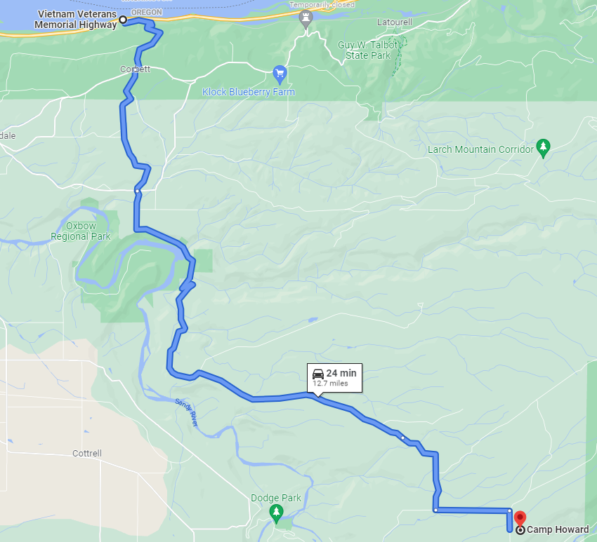

From Sandy, Oregon
- Turn from OR Highway 26 in Sandy onto SE Ten Eyck Road. Proceed north
- Continue on SE Ten Eyck Road [1.5 miles]
- Take the Sharp Left to Stay on SE Ten Eyck Road [1.4 miles]
- Turn Right onto SE Bull Run Road [3.0 miles]
- Continue straight onto SE Warriner Road [1.0 miles]
- Turn Right at the big "Camp Howard" sign and go .2 miles down the gravel road. The Camp Entrance is on the left.
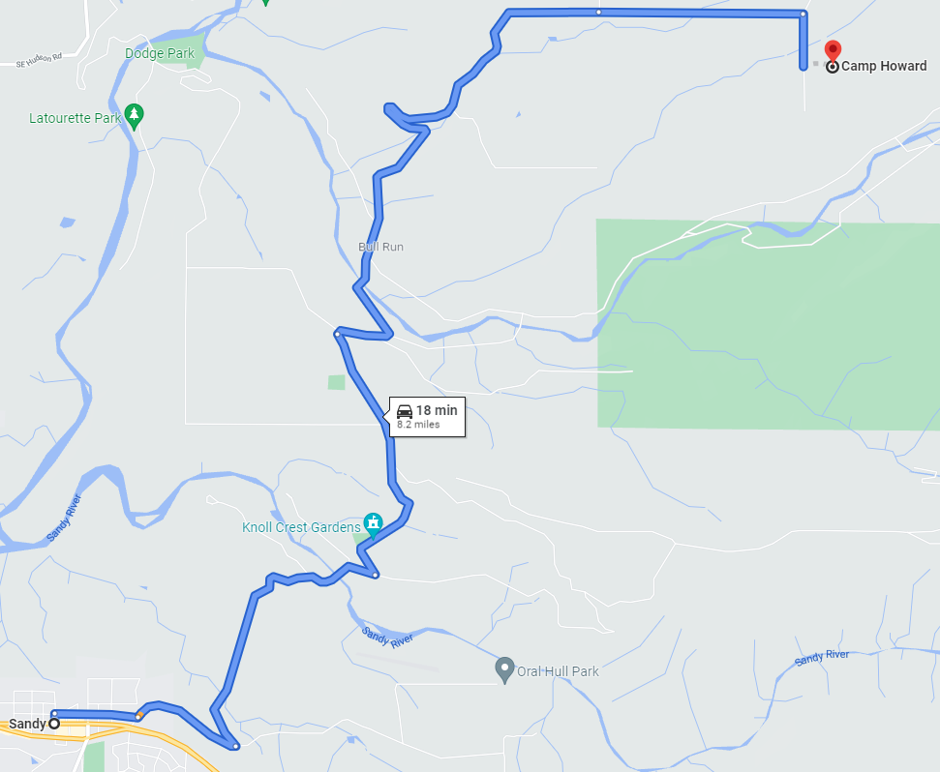

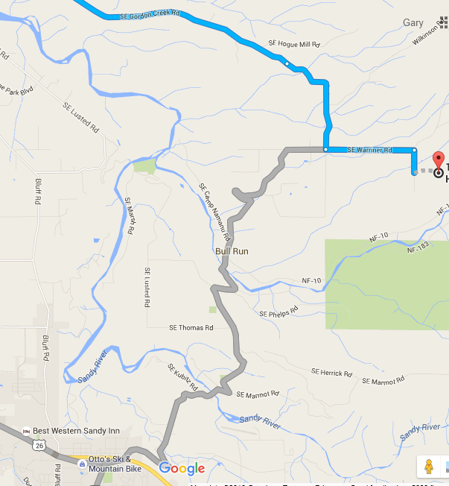
Sandy Oregon
Sandy Oregon
Camp Howard
To Highway I-84

