JHPTS Visual Tracking
and
Pacific Crest Trackers Association
Present a
2021 TRACKING COURSE

At the Oregon State University 4-H Camp
located at 5390 4-H Road NW, Salem, Oregon
(coordinates: 45.0028 -123.1439) [UTM 10T UTM 10T 0448656E / 4983267N]
Web site: http://oregon4hcenter.org/

Dates of Training: September 14-19, 2021

JHPTS Visual Tracking and Pacific Crest Trackers Association will be co-sponsoring a combined tracking training event to include two indivisible learning and practical “hands-on “applications of this “first responder” critical law enforcement and life and death resource. This “six-day” training event will begin with a 3-day Advanced Tracking Training followed by a 3-day course of Basic field and classroom tracking training.

ADVANCED TRACKING COURSE: September 14-16/19 - Students must have a minimum of JHPTS Basic Certification to participate in this portion of the training event.

Class will begin at 0800 on Tuesday, September 14th until 1700 Thursday, September 16th. Students will have the option to participate in the 24-Hour Course. This training class will concentrate on two important areas of our tracking program: It will bring all trainers, designated trainers, Lead Trackers and Instructors up to date on JHPTS Visual Tracking policy changes, certification procedures and training methodology in presenting and documenting every facet of every level of each JHPTS Visual Tracking certification. And, importantly, it will focus upon the critical field skills of sign cutting and aging techniques.

BASIC TRACKING COURSE: (September 17-19) This course is more like a regularly scheduled 24-hour sanctioned training for all tracking levels, but with special emphasis on implementation of the new program changes and procedures at all levels. Class will begin at 0800 on Friday, September 16th until 1400, Sunday, September 19th.

Basic Level 1-2 and Novice students may “sit-in attendance” without direct participation during the Advanced Tracker course for edification, experience and learning prior to start of the Basic/Novice class. All available Advanced Trackers, (Basic Level 3, Apprentice, Journeyman) will participate in and with advanced techniques and simulated situational exercises in the field and classroom to improve understanding and skill development.

The $370 tuition pays for all six training days and all students may attend whatever training is being presented throughout the six days.

Location: All training - Both courses will be at the same facility, address appears in heading of this announcement.

Course Cost: $370.00 per student.
For this fee, according to their time off and availability, the student has several options:
- Attend the 24-hour Basic Tracking Course
- Attend the 24-hour Training Field Management (TFM)/Advanced Tracking course
- Attend the 24-hour TFM/ADV course and attend the 24-hour Basic Course as a tracking student
- Or attend the TFM/ADV and Basic Course as an instructor/trainer student, to learn as much as is possible at all levels for a more total benefit to your tracking and to the program.

Return a completed application to Joel Hardin, 225 Mill Rd., Clearwater, ID 83552 with deposit or full payment. Payment may also be made through the JHPTS website.

Meals & Accommodations: Dormitory style accommodations are available Monday, September 13th through Saturday, September 18th for all students. Student must provide their own bedding and towels. Meals and snacks will be provided from breakfast on Tuesday, September 14th through lunch on Sunday September 19th. Students must “sign in” on roster for meals and lodging accommodations.

BASIC TRACKING COURSE: is open to all participants and interested Novices. There are NO prerequisites for this training presentation. This tracking course is open to all persons with tracking interests regardless of previous experience or training and will focus on primary training for beginning or novice student interests. This will be a certification course for all eligible students. All tracking students will be provided training at an appropriate level for their development and upward progress.

This will begin with registration and lecture including PowerPoint presentation to provide Novice and Basic tracker understanding of training methodology, techniques and procedures. The presentation supports field training by providing student understanding of training methods, manner and objectives. “Tracking” is a first response primary search resource used to verify witness statements, establish the “PLS”, direction of subject travel and following the physical evidence of the missing person. Field training will allow “student tracking team” experimentation and “hands-on,” practice of fundamental tracking techniques. Novice students will progress from initial studying to learn to “see” sign to identifying a print via the five points drawing of the print, to simple aging of the sign, to “step-by-step” every track concept of following an identified sign line as a member of a practical tracking team.

This is a “skill development” training opportunity for Apprentice and Journeyman Tracker students. Students at these levels have acquired Basic Tracker understanding and will be introduced to practical tracking techniques and applications necessary to become a viable resource for SAR missions. Students at all training levels will be individually challenged with additional advanced tracking concepts and techniques. Journeyman Tracker students will be provided advanced training objectives working with Novice and Apprentice students and separately in simulated actual SAR and law enforcement mission scenarios.

Please bring your current training manual, skills books, and tracking logs to this course.
Should you anticipate challenging the certification board for advancement: Request a copy of the “JHPTS Visual Tracking Certification Process,” and follow the directives provided.
Students must initiate the process in writing to their Lead Tracker, Designated Trainer, or any JHPTS Visual Tracking Sign Cutter or Instructor No Later Than Friday, August 27th, 2021.

Student Needs: All Students should be physically fit and equipped for SAR field response. Field practice will continue during any inclement weather, students should be properly prepared with wet/dry, cold/hot weather gear. Knee pads may be helpful. Students need to bring a pen/pencil, notepad, small measuring tape, 5/8 inch doweling or similar, 36 to 40 inches long, with three rubber bands to use as a tracking stick, and a flashlight.

Registration: Students must pre-register by September 1st, 2021 for either of these two courses with a $100 deposit.
If you have any questions regarding the class or class location, or regarding course content/materials to be presented, please contact: Joel Hardin, Joel@jhardin-inc.com or by calling (360-319-9002).
Pre-registered students failing to attend this course without a reasonable excuse will be assessed the $100.00 service fee.

Law Enforcement students will be able to sign a separate roster for documenting continuing education hours, (POST).

Sponsor Information: Primary sponsor is JHPTS Visual Tracking and secondary sponsor Pacific Crest Trackers Association. Site liaison is Michael Black. Contact at MBandJB-Home@comcast.net or by calling Cell: (971-273-3504)

TRAINING COURSE REGISTRATION
TRAINING FIELD MANAGEMENT and ADVANCED TRACKER TRAINING COURSE
September 14-19, 2021
At the
Oregon State University 4-H Camp
5390 4-H Road NW, Salem, Oregon
Course Applicant: Please complete this form and send via email attachment or regular mail to:
Joel@jhardin-inc.com or Joel Hardin, 225 Mill Road, Clearwater, ID 83552
Course Location: | Oregon State University 4-H Camp  5390 4-H Road NW, Salem, Oregon  (coordinates: 45.0028 -123.1439)  [UTM 10T UTM 10T 0448656E / 4983267N]  Web site: http://oregon4hcenter.org/
Course Date: | September 14-19, 2021
Course Name: | Training Field Management and Advanced Tracker Training Course
Student Name:
Mailing Address:
City:
Prov/State: | Postal Code:
Phone #: | Group/Unit/County:
E-Mail Address:
Current JHPTS Certification | (please check one) (you may double click on the appropriate square and change the default value from Not Checked to Checked)
☐ Novice Tracker | ☐ Basic Tracker Level 3 | ☐ Apprentice Tracker
 | ☐ Journeyman Tracker | ☐ Sign Cutter
☐ Deposit Enclosed $100.00 | ☐ Tuition Fee Enclosed $____________
Applicant: Please note any requests, dietary needs or questions that you have and wish a response from the contact person.

TRAINING COURSE REGISTRATION
BASIC TRACKER TRAINING COURSE
September 17, 18, 19, 2021
At the
Oregon State University 4-H Camp
5390 4-H Road NW, Salem, Oregon
Course Applicant: Please complete this form and send via email attachment or regular mail to:
Joel@jhardin-inc.com or Joel Hardin, 225 Mill Road, Clearwater, ID 83552
Course Location: | Oregon State University 4-H Camp  5390 4-H Road NW, Salem, Oregon  (coordinates: 45.0028 -123.1439)  [UTM 10T UTM 10T 0448656E / 4983267N]  Web site: http://oregon4hcenter.org/
Course Date: | September 17, 18, 19, 2021
Course Name: | Basic Tracker Training Course
Student Name:
Mailing Address:
City:
Prov/State: | Postal Code:
Phone #: | Group/Unit/County:
E-Mail Address:
Current JHPTS Certification | (please check one) (you may double click on the appropriate square and change the default value from Not Checked to Checked)
☐ Novice Tracker | ☐ Basic Tracker | ☐ Apprentice Tracker
 | ☐ Journeyman Tracker | ☐ Sign Cutter
☐ Deposit Enclosed $100.00 | ☐ Tuition Fee Enclosed $____________
Applicant: Please note any requests, dietary needs or questions that you have and wish a response from the contact person.

Directions to the OSU 4-H Camp at 5390 4-H Road NW, Salem, Oregon
(coordinates: 45.0028 -123.1439) [UTM 10T UTM 10T 0448656E / 4983267N]
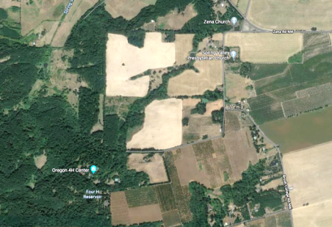
Access to 4-H Camp … intersection of
Brush College Road NW & 4-H Road NW

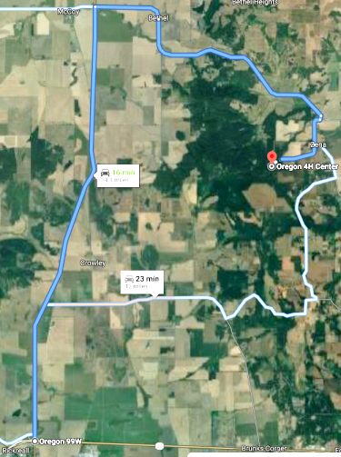
From west of the camp on Pacific Highway OR-99W…
- Head north from the intersection of OR-22 on OR-99W N
(Rickreall, OR) (7.7 miles)
- Turn right onto Bethel Road/Lincoln-Zena Road…
- Continue to follow Bethel Road (1.2 miles)
- Continue onto Zena Road (3.8 miles)
- Turn right onto Lincoln-Zena Rd/Spring Valley Road NW (404 feet)
- Turn right onto Brush College Road NW (0.5 miles)
- Slight right onto 4 H Road NW (0.7 miles)
- Arrive: Oregon 4H Center at 5390 4-H Road NW, Salem, OR

Directions to the OSU 4-H Camp at 5390 4-H Road NW, Salem, Oregon
(coordinates: 45.0028 -123.1439) [UTM 10T UTM 10T 0448656E / 4983267N]

From east of the camp on I-5…
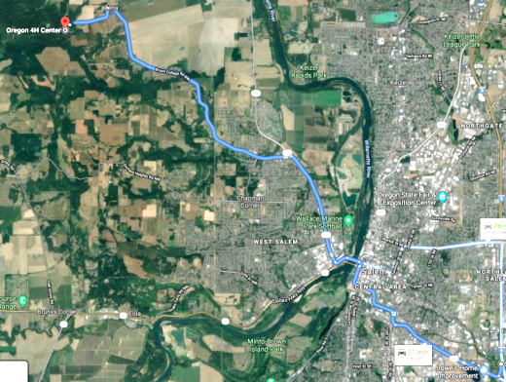
Route Overview: OR-22 W/OR-99E, Business N/Mission Street SE, OR-221 N/Wallace Road NW and Brush College Road NW to 4 H Road NW in Polk County (11.1 miles)
- Take Exit-253 on I-5 and proceed northwest onto Mission Street SE, OR-22 W (0.2 miles)
- Keep right at the fork/overpass, follow signs for Willamette University/City Center and merge onto Mission Street SE (2.1 miles)
- Take the OR-99E, Business exit toward OR-22 W/Willamette University/City Center (0.2 miles)
- Turn left onto OR-22 W/OR-99E, Business N/Bellevue Street SE…
- Continue to follow OR-22 W/OR-99E, Business N (1.2 miles)
- Turn right onto the OR-22 W ramp to Marion Street Bridge (0.1 miles)
- Continue onto OR-22 W/Marion Street NE…
- Continue to follow OR-22 W (0.2 miles)
- Use the right 2 lanes to take the OR-221 exit toward Dayton (0.2 miles)
- At Jersey Mike's Subs, continue onto OR-221 N/Wallace Road NW … Pass by Taco Bell (on the right) (2.0 miles)
- Turn left onto Brush College Road NW (4.7 miles)
- Turn left onto 4 H Road NW (0.7 miles)
- Arrive: Oregon 4H Center at 5390 4-H Road NW, Salem, OR

